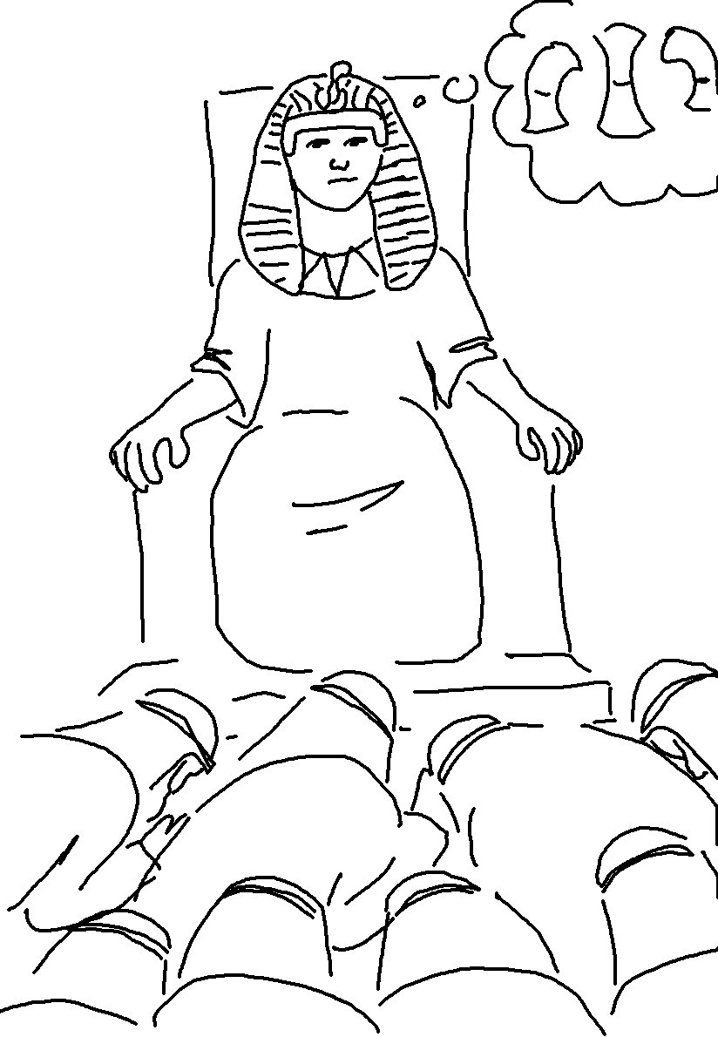
If you are faithful in little things, you will be faithful in large ones. Luke 16:10_{NLT}

